Chris Ricchi

November 11 2023

Probability and Applied Stats

**Stock Trading Evaluator Report**

**Abstract:** The StockTradingSimulatorGUI is a Java application designed for simulating stock trading strategies. It provides users with an interactable interface to evaluate the performance of different trading heuristics on their own imported data. The application incorporates three primary trading algorithms: Relative Strength Index and Moving Average, Buy and Hold, and Trend Following. In this report, we will present a detailed analysis of each algorithm, examining their underlying principles and implementation within the program. The research encompasses an exploration of financial indicators such as RSI, moving average, and trend following strategies. Additionally, the study investigates the impact of the three algorithms on trading outcomes and provides insight on the effectiveness of each in various market conditions. The report concludes with a summary of the simulation results, highlighting key performance metrics such as the number of buys, sells, holds, final balance, shares held, and overall profit. Through this report, readers will gain a comprehensive understanding of the program, its algorithmic capabilities, and the implications of employing these strategies in a real-world market.

**Relative Strength Index**

The Relative Strength Index + Moving Average (RSI+MA) algorithm synergizes the relative strength index and the moving average to create a unique trading strategy. The implementation involves the RSI, which gauges the relative strength of a stock’s recent price movements, signaling potential overbought or oversold conditions. Simultaneously, the moving average smoothens the stock’s price data showing its overlying trend. By combining both, the algorithm seeks to choose opportune moments for buying and selling. A buy signal is triggered when the RSI falls below a predefined threshold, indicating an oversold history, and the stock’s closing price is below the moving average. Conversely, a sell signal occurs when the RSI surpasses a set threshold, indicating an overbought history. One of the notable benefits of this algorithm lies in its ability to react to market momentum, allowing traders to take advantage of price reversals. However, its downside is that using the algorithm includes increased trading frequency, which technically relates to higher trading costs. In terms of real-world applications, many people employ the RSI + MA algorithm when they aim to profit from short to medium-term price movements. It is particularly useful when the stock provides clear evidence of its past trends, which shows traders how to best capitalize on market fluctuations.

**Buy and Hold**

The buy and hold strategy is a simple yet effective investment strategy. The implementation is straightforward: investors acquire stocks with the intention of holding them over extended periods, irrespective of short-term market fluctuations. This long-term strategy offers a unique set of benefits, primarily in reduced trading activity and lower transaction costs. By purchasing less often, the buy and hold strategy is beneficial as a more passive approach that aligns with low risk. However, the downside of this strategy becomes evident during market downturns, as it lacks the agility to respond to changing market conditions quickly. The efficacy of buy and hold is dependent on the overall performance of the selected stocks over time, making it best suited for stable stocks. In terms of real-world applications, this strategy aligns with the objectives of long-term investors mainly. People who are looking to invest in a safe stock suit this strategy best, as it is reliable and relatively stress-free. Nevertheless, its effectiveness is entirely reliant on the success and safety of the chosen stock.

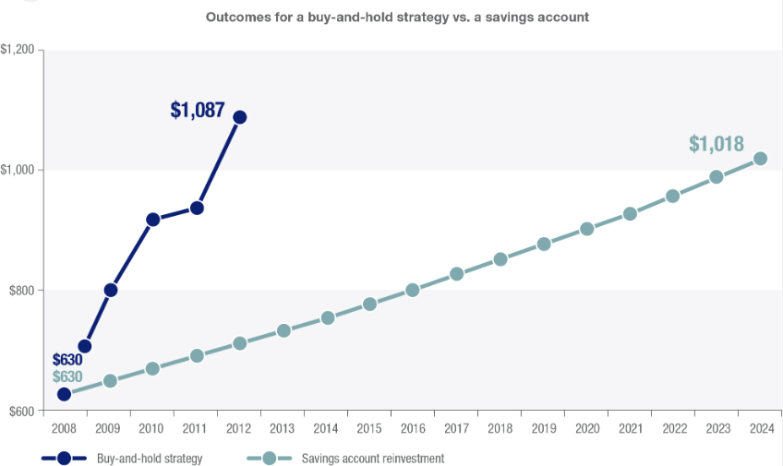

**Trend Following**

The trend following algorithm employs a unique strategy centered around short-term and long-term moving averages. The implementation involves the calculation of these averages to identify trends to make informed trading decisions. A buy signal is generated when the short-term moving average exceeds the long-term moving average, indicating a potential uptrend. Conversely, a sell signal is initiated when the short-term moving average dips below the long-term moving average, indicating a possible downtrend. This algorithm mainly excels in minimizing trades during market indecision, which provides a relatively balanced approach for traders seeking to benefit off of sustained price movements. Trend following mainly benefits in its ability to adapt to market conditions and excel in prolonged trends. However, its downsides surface in potential delays in responding to sudden market reversals, which could result in missed opportunities or losses. In terms of real-world applications, the trend following strategy is commonly used by investors aiming to ride sustained trends. It finds relevance in more advanced trading and algorithmic strategies, with a high-risk high reward yield.

**Comparative Analysis of the Algorithms**

The three discussed algorithms each represent unique approaches to stock trading with their own characteristics, benefits, and drawbacks. The RSI+MA algorithm combines the momentum-based power of the relative strength index with the ability of trend revealing using the moving average. This combination adapts well at capturing trends and responding to market momentum, making it suitable for traders looking to capitalize on market reversals. However, its increased trading frequency makes it high risk. In contrast, the buy and hold strategy has a more simplistic approach with a long-term perspective, minimizing transaction costs by avoiding frequent trading. This approach is mainly attractive to traders who are looking to avoid risk. However, the buy and hold strategy lacks the ability to respond promptly to changing market conditions, particularly downtrends. The effectiveness of the buy and hold strategy mainly relies on the chosen stock’s overall performance, making it well-suited for stable assets with reliable growth. The trend following algorithm, however, bridges the gap between the two other strategies by leveraging short-term and long-term moving averages to identify and capitalize on trends. This approach excels in ever-changing markets by adapting to changing conditions and capturing trends. However, its potential drawback lies in a delayed response to sudden market reversals, potentially resulting in missed opportunities or losses.

In real-world applications, the choice between these strategies relies on an investor’s risk tolerance, investment goals, and market expectations. Traders seeking short to medium-term opportunities may choose to go with the RSI+MA strategy, while long-term investors may find solace in the simplicity of the buy and hold strategy. The trend following strategy, with its ability to follow trends, offers a fair middle ground for those looking to balance active trading with a safe approach. Ultimately, the selection of the three algorithms relies heavily on the investor’s risk tolerance, the current market, and the type of stock. The stock trading program provides a platform for users to explore the three heuristics with their own data to see which trends they see fit for them.

**Results**

Analyzing the performance of the three algorithms applied to Apple stock last year reveals interesting results. Starting with an initial balance of $50,000, the RSI+MA algorithm engaged in only 5 buy transactions, 4 sell transactions, and 242 holding periods, resulting in a profit of $7,944.55. In comparison, the buy and hold strategy exhibited a more conservative approach, with obviously only a single buy transaction, no sells, and 250 holding periods, accumulating a profit of $12,905.69. Meanwhile the trend following strategy, similar to RSI+MA, executed 5 buys and 4 sells, holding for 242 periods, but generated the highest profit of $14,807.45.

The RSI+MA strategy showcased its ability to capture short to medium-term market movements by strategically buying and selling based on RSI and MA indicators. However, its susceptibility to increased transaction frequency poses a challenge. The buy and hold strategy, characterized by its simplicity and long-term focus, demonstrated resilience in the face of all market fluctuations. On the other hand, the trend following the strategy utilized a combination of short and long-term moving averages and struck a balance by adapting to changing market conditions and capturing trends. These results underscore the trade-off between frequency and stability. While the RSI+MA and trend following algorithms may offer more dynamic responses to market shifts, they also incur high transaction costs while the buy and hold strategy minimizes overall costs.

When comparing the results, it's evident the buy and hold strategy yielded the highest profit. Its simplicity and passive nature allow the investor to benefit from the growth of the stock over time. However, the trend following strategy closely trailed behind, showing the potential for actively managed approaches to capitalize on trends. The RSI+MA strategy, while generally profitable, is more intricate and offers a trade-off between frequent trading and potential gains. For future real-world use, investors need to weigh the results against their own risk tolerance, time horizon, and personal preference. RSI+MA and trend following may be more suitable for those comfortable with active management as they are more willing to navigate short-term volatility. In contrast, the buy and hold strategy aligns well with passing, long-term investment as shown by the Apple stock.

**Conclusion**

It is apparent that the RSI+MA, buy and hold, and the trend following strategies all have their own landscape of positive and negatives. The RSI+MA strategy, leveraging the relative strength index and moving average, demonstrated a capacity for short to medium-term maneuvering. Its profitability, specifically in our case of $7944, 55, demonstrates its ability to capture market movements and buy or sell at important moments. The buy and hold strategy, characterized by its simplicity and long-term perspective, yielded a profit of $12,905.69. This approach minimizes transactions by executing a single buy and holding the investment over a period of time. However, it falls short in actively responding to market fluctuations in the short-term. Lastly, the trend following strategy integrated both short and long-term moving averages, showcasing the ability to adapt to changing market conditions. With a profit of $14,807.45, it positioned itself as the leading heuristic in the list of algorithms that we created. However, all three algorithms are beneficial choices depending on the type of stock you choose and your level of risk. In essence, each strategy offers diverse tools for investors to use to capitalize in the world of trading. Ultimately, the effectiveness of a strategy hinges on market conditions, risk management, and each investor’s unique investment preferences.

A screenshot of a computer screen

Works Cited

RSI Information: <https://www.investopedia.com/terms/r/rsi.asp>

Buy and Hold Information: <https://www.investopedia.com/terms/b/buyandhold.asp>

Trend Following Information: <https://www.investopedia.com/terms/t/trendtrading.asp>